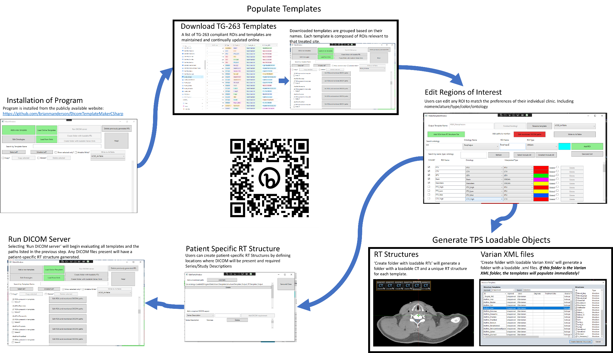

Supplementary Figure 3: Workflow of the program with images captured during use.